[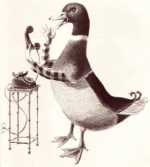](http://www.google.ae/url?sa=i&rct=j&q=the+magic+finger&source=images&cd=&cad=rja&docid=Jkejtag0AksujM&tbnid=srifix3GqYiYfM:&ved=0CAUQjRw&url=http://www.vintagechildrensbooksmykidloves.com/2011/10/magic-finger.html&ei=W5utUdCkO8matQaa1IA4&bvm=bv.47244034,d.Yms&psig=AFQjCNEhSE6LIlOmg0P83bBkwoJt0lKFNg&ust=1370418375306876)[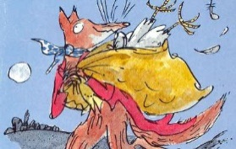](http://www.google.ae/url?sa=i&rct=j&q=Fanatsic+Mr+Fox&source=images&cd=&cad=rja&docid=FaUSsXSceeELaM&tbnid=EwRVCiE2r2nJUM:&ved=0CAUQjRw&url=http://screenrant.com/fox-searchlight-fantastic-mr-fox-pauly-8097/&ei=FZutUfGtBsqNtAbJ1wE&bvm=bv.47244034,d.Yms&psig=AFQjCNFUBL4iucoTGppc88P8zGwmqCjfJg&ust=1370418314108170)[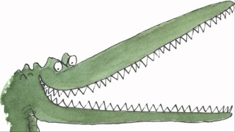](http://www.google.ae/url?sa=i&source=images&cd=&cad=rja&docid=wLuHCvixdrfItM&tbnid=G-QOu2J3EWFnSM:&ved=0CAgQjRwwAA&url=http://www.youtube.com/watch?v=r3dA2goH08g&ei=5pqtUcGMJ8bvsgb0lIC4Dw&psig=AFQjCNE4lPtyG3S6qMq-W097pzksZbcRCA&ust=1370418278694382)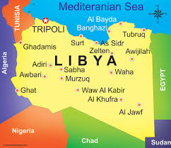

[Roald Dahl writes](http://www.roalddahlfans.com/pictures/picture12.php) The Magic Finger in 1966.

Mr. Fox is written in 1970.

In 1978 he writes The Enormous Crocodile.

He suffers serious injuries as result of plane crash in Libya in 1940.

Meets future wife, actress [Patricia Neal](http://www.roalddahlfans.com/pictures/picture7.php) in 1951.

[Roald Dahl dies](http://www.roalddahlfans.com/pictures/picture12.php) November 23, 1990 in Oxford, England.

Daughter Ophelia Magdalena born May 12, 1964

Roald Dahl was born September 13, 1916 in Llandaff.